Project Design Phase-II
Technology Stack (Architecture & Stack)
Date | 01 July 2026
Team ID
Project Name | Nutrition Assistant Using MERN stack
Maximum Marks | 4 Marks

Technical Architecture:
The Deliverable shall include the architectural diagram as below and the information as per the table1 & table 2
Example: Architecture for India's Agricultural Crop Production Analysis
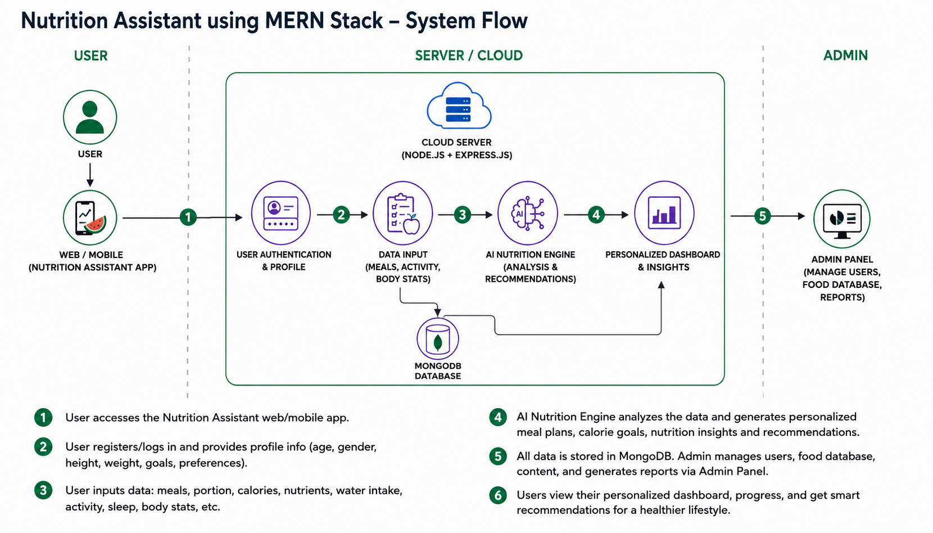

Guidelines:
Include all the processes (As an application logic / Technology Block)
Provide infrastructural demarcation (Local / Cloud)
Indicate external interfaces (third party API’s etc.)
Indicate Data Storage components / services
Indicate interface to machine learning models (if applicable)

Table-1 : Components & Technologies:
S.No | Component | Description | Technology
1. | User Interface | How user interacts with application e.g. Web UI | HTML5, CSS3, Bootstrap 5, JavaScript
2. | Application Logic | Visualization and interaction processing logic | Tableau Public Dashboard & Story Engine
3. | Database | Data Type, Configurations etc. | Microsoft Excel (.xlsx) Static Data
4. | Infrastructure | Application Deployment on Cloud | Vercel (Web Hosting), Tableau Public (Data Hosting)

Table-2: Application Characteristics:
S.No | Characteristics | Description | Technology
1. | Open-Source Frameworks | List the open-source frameworks used | Bootstrap 5 CSS Framework
2. | Security Implementations | Security / access controls implemented | Vercel Auto SSL/TLS Encryption
3. | Scalable Architecture | Justify the scalability of architecture | Tableau Public CDN distributed architecture
4. | Performance | Design consideration for the performance | In-memory Tableau data engine processing 345k rows
References:
https://www.tableau.com/developer
https://data.gov.in/
https://agriwelfare.gov.in/
https://getbootstrap.com/docs/
https://vercel.com/docs

